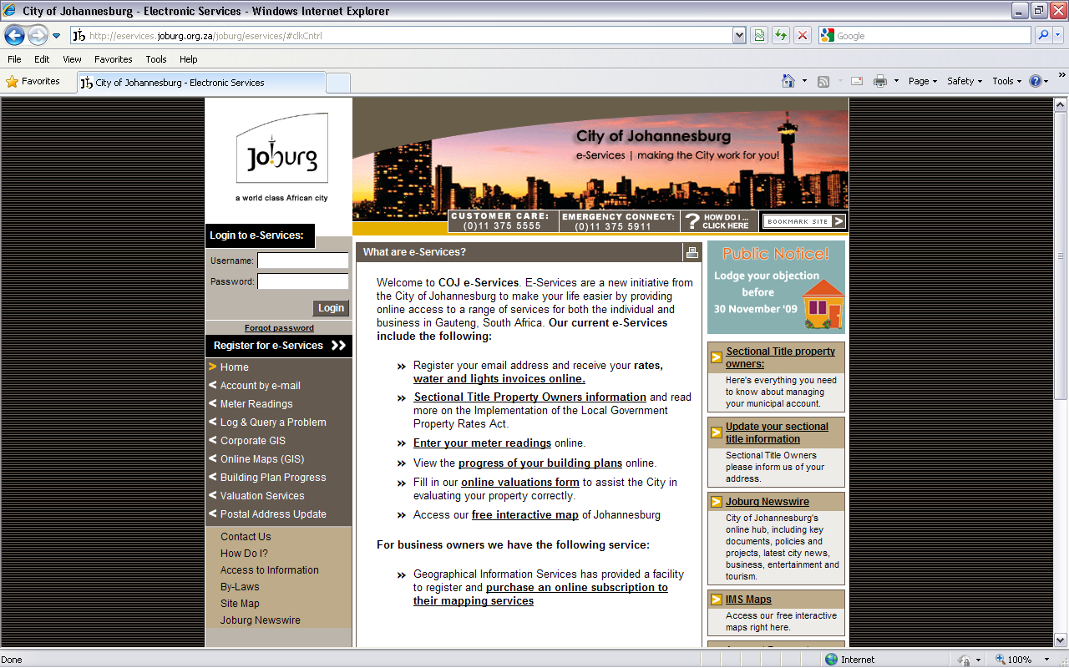
Log in
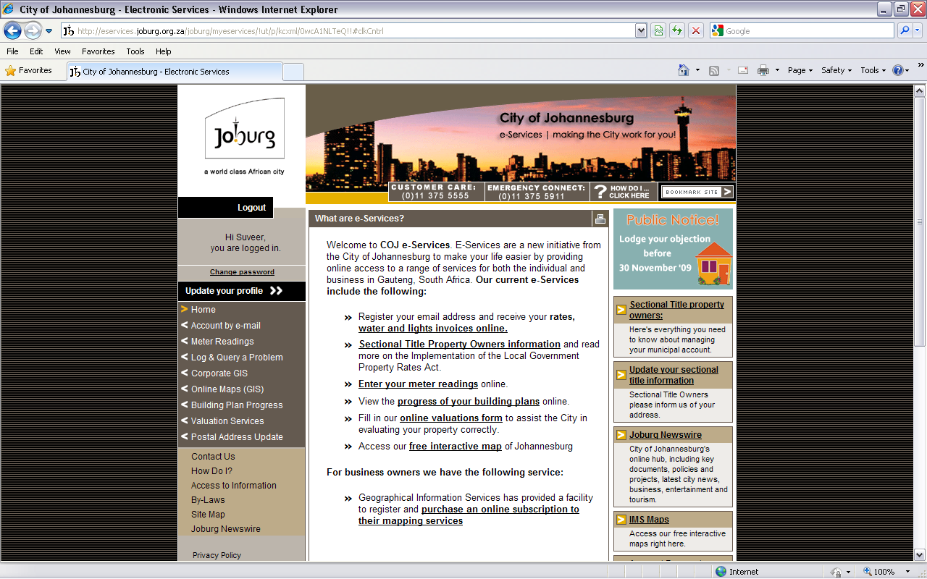

Click on “Register your email address and receive your rates, water and lights invoices online.”
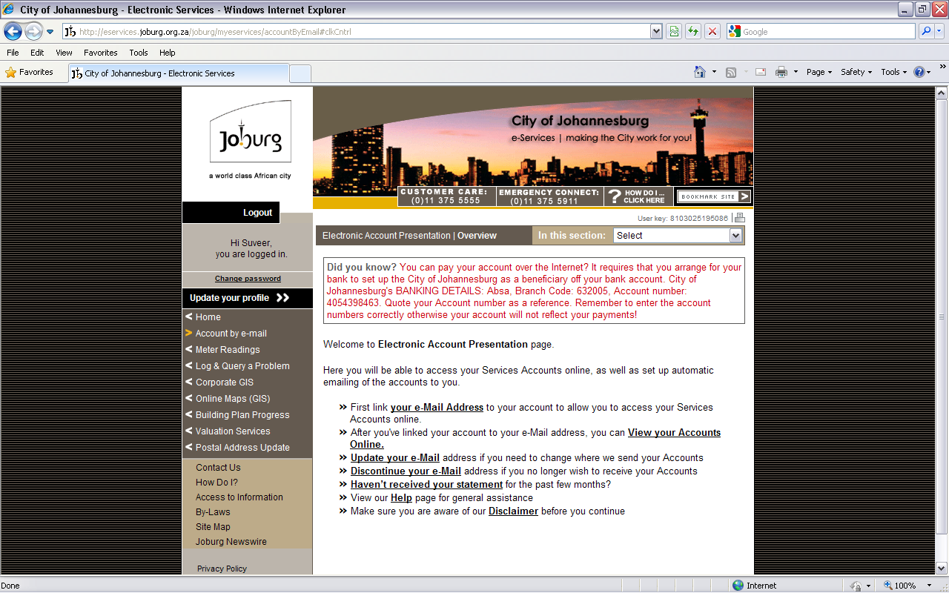
Click on “View your Accounts Online.”
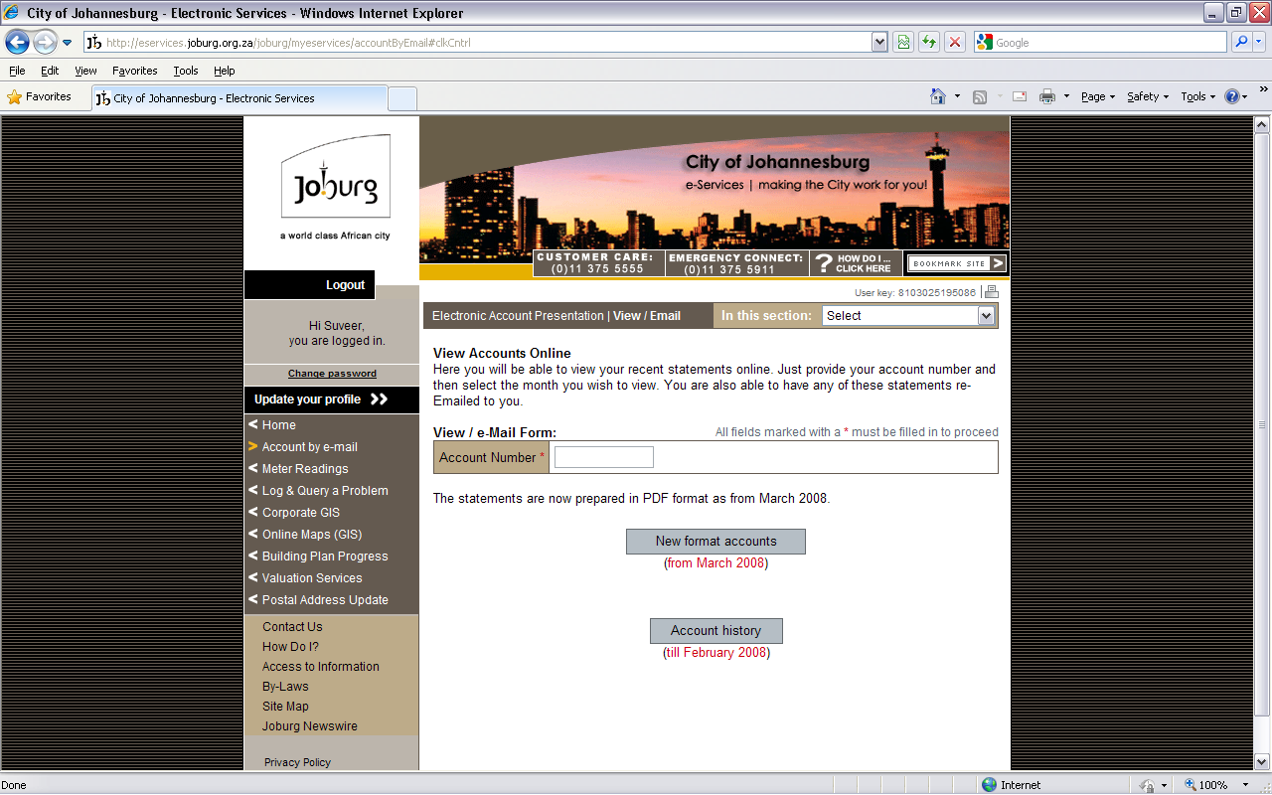
Input account number and click on “new format accounts”
If u get an error as below: click on the blue part on top and click display blocked content.
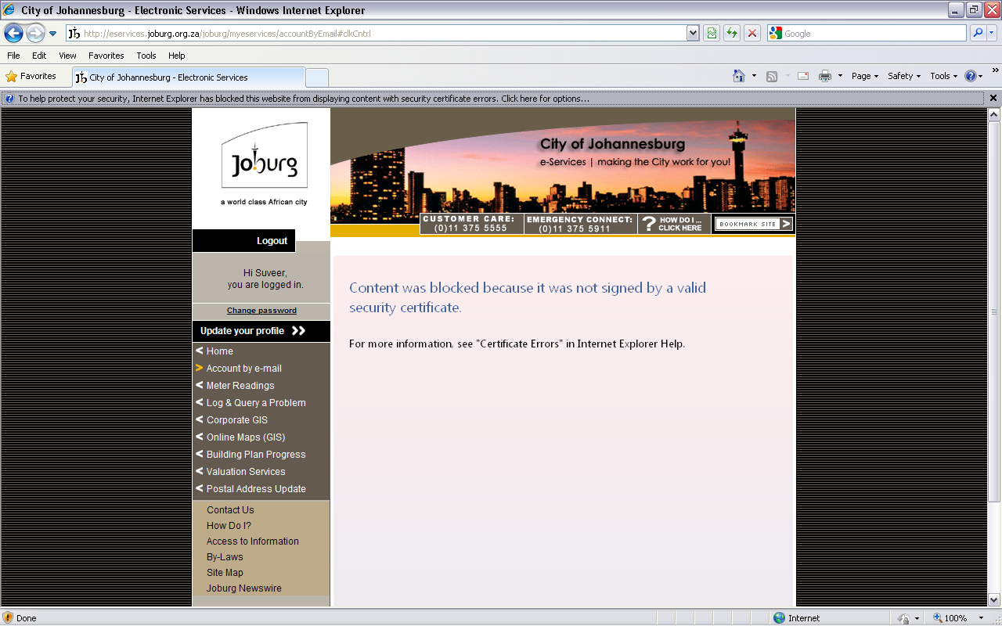
Then go through the process a little above and you will get to your statements.



